DISTRICT OFFICE

Daniel Ward
Superintendent of Schools

Kevin J. Polunci
Executive Director of Business and Human Resources

80 East LaBarge, Hudson Falls, NY 12839
Phone: (518) 747-2121

Michael T. DeCaprio
Assistant Superintendent for
Education and Accountability

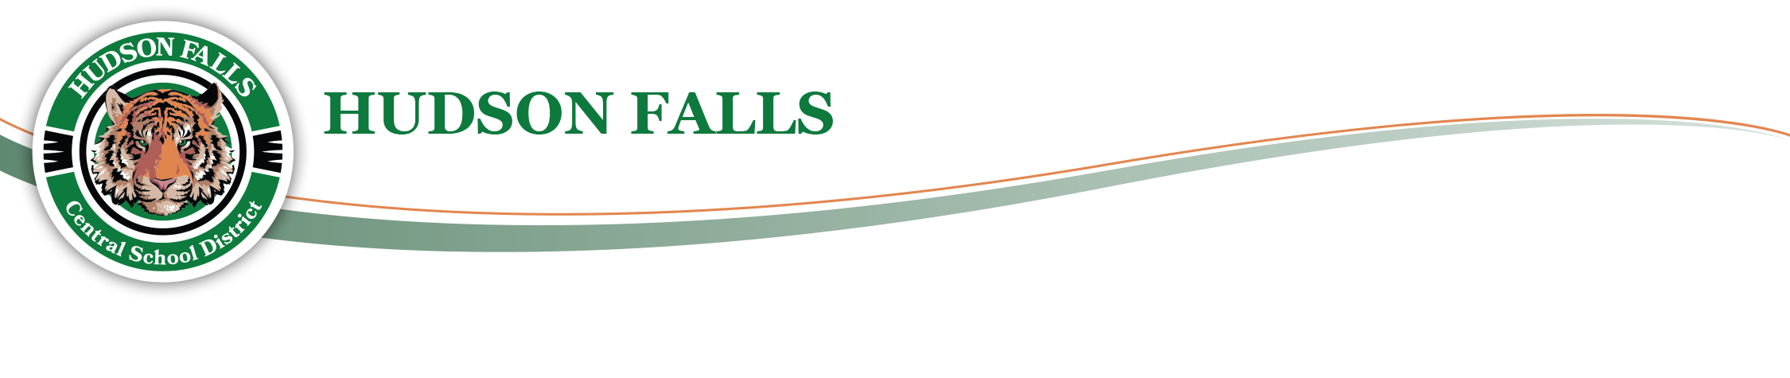

September 15, 2022

Dear Tiger Families,

Today at approximately 2:45pm there was a minor bus accident that involved one of our school buses backing into a utility pole while carrying 14 students. The accident was swiftly reported to the transportation dispatcher and the District’s bus accident protocol was immediately enacted with school administration and medical personnel being dispatched to the scene.

The students and driver were evaluated at the scene and transported back to the Intermediate School by a replacement bus and replacement driver. After arriving at the Intermediate School the parents and guardians of all students (that had not already been contacted directly by their children) were contacted to arrange for student pick up.

The safety and well-being of our students is always our first priority. My sincerest thanks to all that responded to the scene today to evaluate and reassure our students. Additionally, thank you to all the parents and guardians for your cooperation while we responded to this situation. I apologize for any inconvenience that this accident may have caused you or your children.

Sincerely,
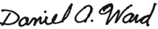

Daniel A. Ward

